*Lab experiments*

**Roll no: 230701391**

**Name: Musa Haji**

**Class: CSE-c III**

**Subject: Fundamentals of data science (CS2334)**

**Experiment: 01**

import pandas as pd import numpy as np import seaborn as sns import matplotlib.pyplot as plt

%matplotlib inline

data=pd.read_csv('/content/Iris_Dataset.csv') data

**Id SepalLengthCm SepalWidthCm PetalLengthCm PetalWidthCm variety**

1. 1 5.1 3.5 1.4 0.2 Iris-setosa
2. 2 4.9 3.0 1.4 0.2 Iris-setosa
3. 3 4.7 3.2 1.3 0.2 Iris-setosa
4. 4 4.6 3.1 1.5 0.2 Iris-setosa
5. 5 5.0 3.6 1.4 0.2 Iris-setosa

**...** ... ... ... ... ... ...

1. 146 6.7 3.0 5.2 2.3 Iris-virginica
2. 147 6.3 2.5 5.0 1.9 Iris-virginica
3. 148 6.5 3.0 5.2 2.0 Iris-virginica
4. 149 6.2 3.4 5.4 2.3 Iris-virginica
5. 150 5.9 3.0 5.1 1.8 Iris-virginica
6. rows × 6 columns

data.info()

<class 'pandas.core.frame.DataFrame'> RangeIndex: 150 entries, 0 to 149

Data columns (total 6 columns):

# Column Non-Null Count Dtype

--- ------ -------------- -----

1. Id 150 non-null int64
2. SepalLengthCm 150 non-null float64
3. SepalWidthCm 150 non-null float64
4. PetalLengthCm 150 non-null float64
5. PetalWidthCm 150 non-null float64
6. variety 150 non-null object dtypes: float64(4), int64(1), object(1) memory usage: 7.2+ KB data.describe()

**Id SepalLengthCm SepalWidthCm PetalLengthCm PetalWidthCm count** 150.000000 150.000000 150.000000 150.000000 150.000000

**mean** 75.500000 5.843333 3.054000 3.758667 1.198667 **std** 43.445368 0.828066 0.433594 1.764420 0.763161

**min** 1.000000 4.300000 2.000000 1.000000 0.100000

**25%** 38.250000 5.100000 2.800000 1.600000 0.300000

**50%** 75.500000 5.800000 3.000000 4.350000 1.300000 **75%** 112.750000 6.400000 3.300000 5.100000 1.800000 **max** 150 000000 7 900000 4 400000 6 900000 2 500000

data.value_counts('variety')

**count**

**variety**

**Iris-setosa** 50

**Iris-versicolor** 50

**Iris-virginica** 50

sns.countplot(x='variety',data=data,) plt.show()

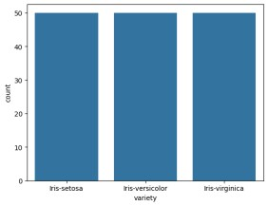

dummies=pd.get_dummies(data.variety) FinalDataset=pd.concat([pd.get_dummies(data.variety),data.iloc[:,[0,1,2,3]]], axis=1)

FinalDataset.head()

**Iris-setosa Iris-versicolor Iris-virginica Id SepalLengthCm SepalWidthCm PetalLengthCm 0** True False False 1 5.1 3.5 1.4 **1** True False False 2 4.9 3.0 1.4 **2** True False False 3 4.7 3.2 1.3 **3** True False False 4 4.6 3.1 1.5 **4**

True False False 5 5 0 3 6 1 4

sns.scatterplot(x='SepalLengthCm',y='SepalWidthCm',hue='variety',data=data,) <Axes: xlabel='SepalLengthCm', ylabel='SepalWidthCm'>

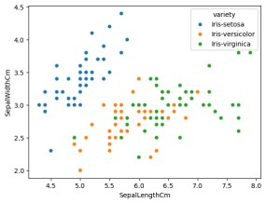

sns.scatterplot(x='PetalLengthCm',y='PetalWidthCm',hue='variety',data=data,)

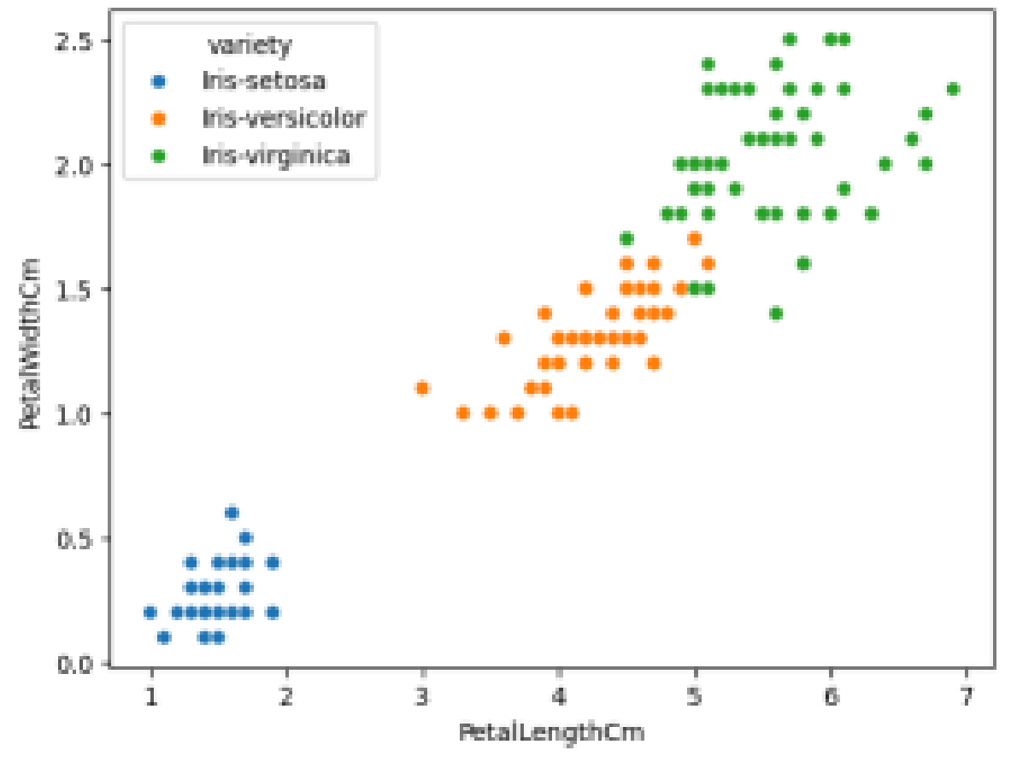

sns.pairplot(data,hue='variety',height=3);

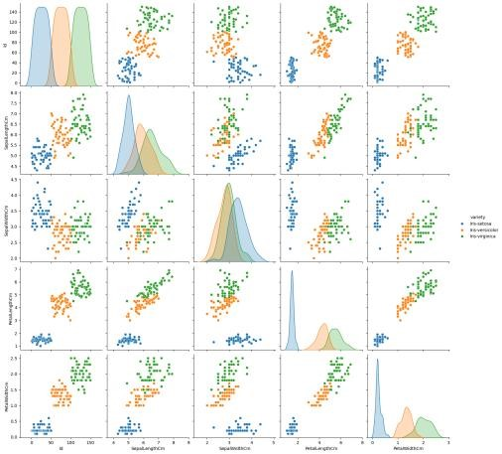

plt.show()

sns.FacetGrid(data,hue='variety',height=5).map( sns.histplot,'PetalLengthCm').add_legend(); plt.show();

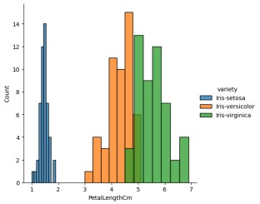

sns.FacetGrid(data,hue='variety',height=5).map( sns.histplot,'PetalWidthCm').add_legend(); plt.show();

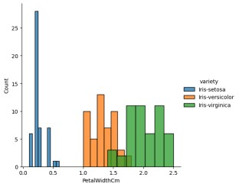

sns.FacetGrid(data,hue='variety',height=5).map( sns.histplot,'SepalLengthCm').add_legend(); plt.show();

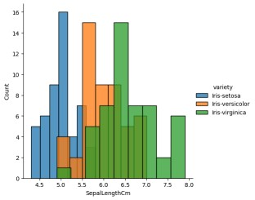

sns.FacetGrid(data,hue='variety',height=5).map(sns.histplot,'SepalWidthCm').a dd_legend();

plt.show();

**Lab experiments**

**Roll no: 230701391**

**Name: Musa Haji**

**Class: CSE-C III**

**Subject: Fundamentals of data science (CS2334)**

**Experiment: 02**

import numpy as np array=np.random.randint(1,100,9) array array([83, 25, 19, 47, 62, 15, 96, 39, 51]) np.sqrt(array) array([9.11043358, 5. , 4.35889894, 6.8556546 , 7.87400787, 3.87298335, 9.79795897, 6.244998 , 7.14142843]) array.ndim

1. new_array=array.reshape(3,3) new_array

array([[83, 25, 19], [47, 62, 15],

[96, 39, 51]]) new_array.ndim

1. new_array.ravel()

array([83, 25, 19, 47, 62, 15, 96, 39, 51]) newm=new_array.reshape(3,3) newm

array([[83, 25, 19], [47, 62, 15],

[96, 39, 51]]) newm[2,1:3] array([39, 51]) newm[1:2,1:3]

array([[62, 15]]) new_array[0:3,0:0] array([], shape=(3, 0), dtype=int64) new_array[0:2,0:1]

array([[83], [47]]) new_array[0:3,0:1]

array([[83], [47],

[96]]) new_array[1:3]

array([[47, 62, 15],

[96, 39, 51]])

**Lab experiments**

**Roll no: 230701391**

**Name: Musa Haji**

**Class: CSE-C III**

**Subject: Fundamentals of data science (CS2334)**

**Experiment: 03**

import numpy as np import pandas as pd list=[[1,'Smith',50000],[2,'Jones',60000]]

df=pd.DataFrame(list) df

**0 1 2**

1. 1 Smith 50000
2. 2 Jones 60000

df.columns=['Empd','Name','Salary'] df

**Empd Name Salary**

1. 1 Smith 50000
2. 2 Jones 60000

df.info()

<class 'pandas.core.frame.DataFrame'>

RangeIndex: 2 entries, 0 to 1 Data columns (total 3 columns):

# Column Non-Null Count Dtype

--- ------ -------------- -----

1. Empd 2 non-null int64
2. Name 2 non-null object 2 Salary 2 non-null int64 dtypes: int64(2), object(1) memory usage: 176.0+ bytes df=pd.read_csv("/content/50_Startups.csv") df.info()

<class 'pandas.core.frame.DataFrame'> RangeIndex: 50 entries, 0 to 49 Data columns (total 5 columns):

# Column Non-Null Count Dtype

--- ------ -------------- -----

1. R&D Spend 50 non-null float64
2. Administration 50 non-null float64
3. Marketing Spend 50 non-null float64
4. State 50 non-null object 4 Profit 50 non-null float64 dtypes: float64(4), object(1) memory usage: 2.1+ KB df.head()

**R&D Spend Administration Marketing Spend State Profit**

1. 165349.20 136897.80 471784.10 New York 192261.83
2. 162597.70 151377.59 443898.53 California 191792.06
3. 153441.51 101145.55 407934.54 Florida 191050.39
4. 144372.41 118671.85 383199.62 New York 182901.99
5. 142107 34 91391 77 366168 42 Florida 166187 94

df.tail()

**R&D Spend Administration Marketing Spend State Profit**

1. 1000.23 124153.04 1903.93 New York 64926.08
2. 1315.46 115816.21 297114.46 Florida 49490.75
3. 0.00 135426.92 0.00 California 42559.73
4. 542.05 51743.15 0.00 New York 35673.41
5. 0 00 116983 80 45173 06 California 14681 40

import numpy as np import pandas as pd

df=pd.read_csv("/content/employee.csv") df.head()

**emp id name salary**

1. 1 SREE VARSSINI K S 5000
2. 2 SREEMATHI B 6000
3. 3 SREYA G 7000
4. 4 SREYASKARI MULLAPUDI 5000
5. 5 SRI AKASH U G 8000

df.tail()

**emp id name salary**

1. 3 SREYA G 7000
2. 4 SREYASKARI MULLAPUDI 5000
3. 5 SRI AKASH U G 8000
4. 6 SRI HARSHAVARDHANAN R 3000
5. 7 SRI HARSHAVARDHANAN R 6000

df.info()

<class 'pandas.core.frame.DataFrame'> RangeIndex: 7 entries, 0 to 6 Data columns (total 3 columns):

# Column Non-Null Count Dtype

--- ------ -------------- -----

1. emp id 7 non-null int64
2. name 7 non-null object 2 salary 7 non-null int64 dtypes: int64(2), object(1) memory usage: 296.0+ bytes df.salary

**salary**

1. 5000
2. 6000
3. 7000
4. 5000
5. 8000
6. 3000
7. 6000

type(df.salary)

**pandas.core.series.Series** def __init__(data=None, index=None, dtype: Dtype | None=None, name=None, copy: bool | None=None, fastpath: bool=False) -> None

One-dimensional ndarray with axis labels (including time series).

Labels need not be unique but must be a hashable type. The object supports both integer- and label-based indexing and provides a host of methods for performing operations involving the index. Statistical

th d f d h b idd t t ti ll l d

df.salary.mean()

5714.285714285715 df.salary.median()

6000.0 df.salary.mode()

**salary**

1. 5000
2. 6000

df.salary.var()

2571428.5714285714 df.salary.std()

1603.5674514745463 df.describe()

**emp id salary**

**count** 7.000000 7.000000 **mean** 4.000000 5714.285714 **std** 2.160247 1603.567451 **min** 1.000000 3000.000000

**25%** 2.500000 5000.000000

**50%** 4.000000 6000.000000

**75%** 5.500000 6500.000000 **max** 7 000000 8000 000000

df.describe(include='all')

**emp id name salary**

**count** 7.000000 7 7.000000

**unique** NaN 6 NaN **top** NaN SRI HARSHAVARDHANAN R NaN

**freq** NaN 2 NaN

**mean** 4.000000 NaN 5714.285714 **std** 2.160247 NaN 1603.567451 **min** 1.000000 NaN 3000.000000 **25%** 2.500000 NaN 5000.000000

**50%** 4.000000 NaN 6000.000000

**75%** 5.500000 NaN 6500.000000 **max** 7 000000 NaN 8000 000000

empCol=df.columns empCol

Index(['emp id', 'name ', 'salary'], dtype='object') emparray=df.values emparray array([[1, 'SREE VARSSINI K S', 5000],

[2, 'SREEMATHI B', 6000],

[3, 'SREYA G', 7000],

[4, 'SREYASKARI MULLAPUDI', 5000],

[5, 'SRI AKASH U G', 8000],

[6, 'SRI HARSHAVARDHANAN R', 3000],

[7, 'SRI HARSHAVARDHANAN R', 6000]], dtype=object) employee_DF=pd.DataFrame(emparray,columns=empCol) employee_DF

**emp id name salary**

1. 1 SREE VARSSINI K S 5000
2. 2 SREEMATHI B 6000
3. 3 SREYA G 7000
4. 4 SREYASKARI MULLAPUDI 5000
5. 5 SRI AKASH U G 8000
6. 6 SRI HARSHAVARDHANAN R 3000
7. 7 SRI HARSHAVARDHANAN R 6000

**Lab experiments**

**Roll no: 230701391**

**Name: Musa Haji**

**Class: CSE-C III**

**Subject: Fundamentals of data science (CS2334) Experiment: 04**

#sample calculation for low range(lr) , upper range (ur),percentile import numpy as np

array=np.random.randint(1,100,16) # randomly generate 16 numbers between 1 to

100 array array([27, 50, 44, 6, 58, 61, 23, 86, 67, 20, 75, 7, 79, 61, 90, 54]) array.mean()

50.5 np.percentile(array,25)

26.0 np.percentile(array,50)

56.0 np.percentile(array,75)

69.0 np.percentile(array,100)

90.0

#outliers detection def outDetection(array): sorted(array)

Q1,Q3=np.percentile(array,[25,75]) IQR=Q3-Q1 lr=Q1-(1.5*IQR) ur=Q3+(1.5*IQR) return lr,ur lr,ur=outDetection(array) lr,ur

(-38.5, 133.5)

import seaborn as sns %matplotlib inline sns.displot(array)

<seaborn.axisgrid.FacetGrid at 0x78f3291c2710>

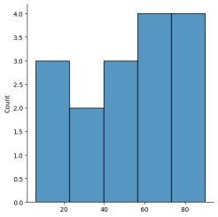

sns.distplot(array) sns.distplot(array)

<Axes: ylabel='Density'>

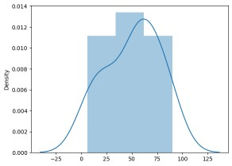

new_array=array[(array>lr) & (array<ur)] new_array array([27, 50, 44, 6, 58, 61, 23, 86, 67, 20, 75, 7, 79, 61, 90, 54]) sns.displot(new_array)

<seaborn.axisgrid.FacetGrid at 0x78f2e09bb580>



lr1,ur1=outDetection(new_array) lr1,ur1 (-38.5, 133.5)

final_array=new_array[(new_array>lr1) & (new_array<ur1)]

final_array array([27, 50, 44, 6, 58, 61, 23, 86, 67, 20, 75, 7, 79, 61, 90, 54]) sns.distplot(final_array)



**Lab experiments**

**Roll no: 230701391**

**Name: Musa Haji**

**Class: CSE-C III**

**Subject: Fundamentals of data science (CS2334)**

**Experiment: 05**

import numpy as np import pandas as pd df=pd.read_csv("Hotel_Dataset.csv")

df

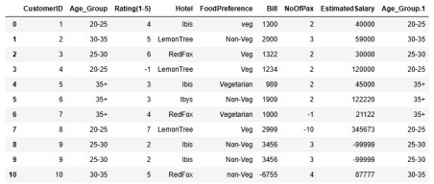

df.duplicated()

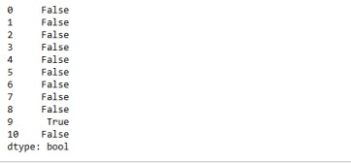.

df.info()

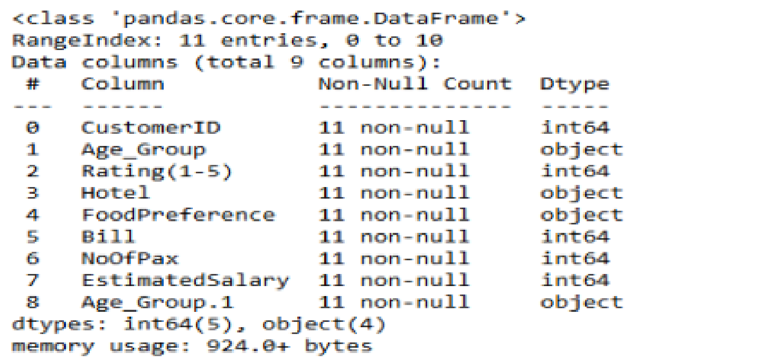

df.drop_duplicates(inplace=True)

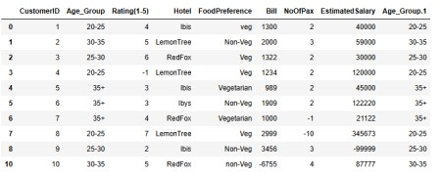df len(df) 10 index=np.array(list(range(0,len(df)))) df.set_index(index,inplace=True)

index

array([0, 1, 2, 3, 4, 5, 6, 7, 8, 9])

df

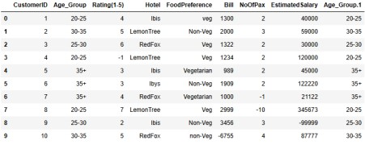

df.drop(['Age_Group.1'],axis=1,inplace=True)

df

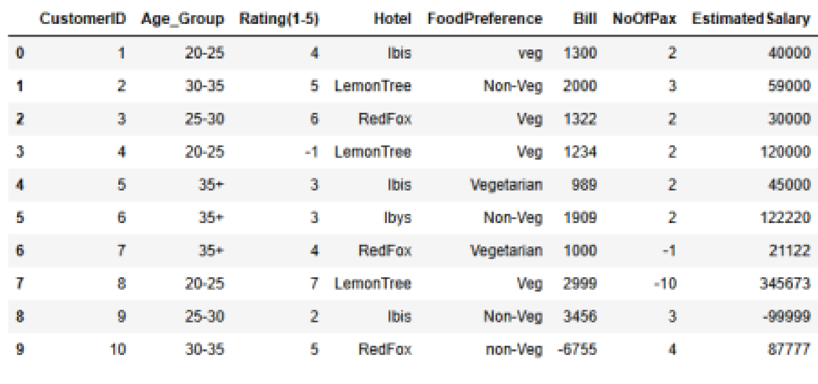

df.CustomerID.loc[df.CustomerID<0]=np.nan df.Bill.loc[df.Bill<0]=np.nan df.EstimatedSalary.loc[df.EstimatedSalary<0]=np.nan

df

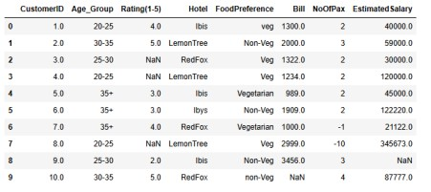

df['NoOfPax'].loc[(df['NoOfPax']<1) | (df['NoOfPax']>20)]=np.nan df

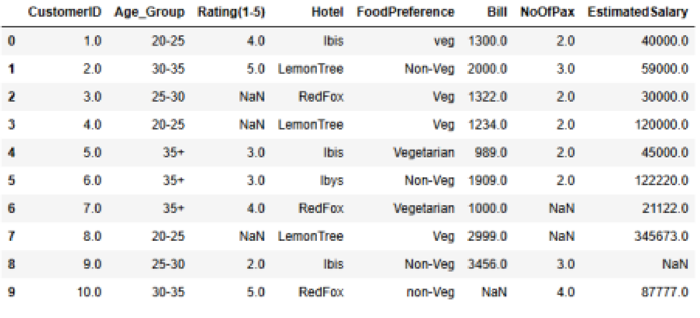

df.Age_Group.unique()

array(['20-25', '30-35', '25-30', '35+'], dtype=object)

df.Hotel.unique()

array(['Ibis', 'LemonTree', 'RedFox', 'Ibys'], dtype=object) df.Hotel.replace(['Ibys'],'Ibis',inplace=True) df.FoodPreference.unique

<bound method Series.unique of 0 veg

1. Non-Veg
2. Veg
3. Veg
4. Vegetarian
5. Non-Veg
6. Vegetarian
7. Veg
8. Non-Veg
9. non-Veg

Name: FoodPreference, dtype: object>

df.FoodPreference.replace(['Vegetarian','veg'],'Veg',inplace=True) df.FoodPreference.replace(['non-Veg'],'Non-Veg',inplace=True) df.EstimatedSalary.fillna(round(df.EstimatedSalary.mean()),inplace=True) df.NoOfPax.fillna(round(df.NoOfPax.median()),inplace=True) df['Rating(1-5)'].fillna(round(df['Rating(1-5)'].median()), inplace=True) df.Bill.fillna(round(df.Bill.mean()),inplace=True) df

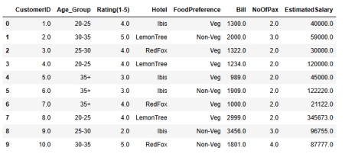

**Lab experiments**

**Roll no: 230701391**

**Name: Musa Haji**

**Class: CSE-C III**

**Subject: Fundamentals of data science (CS2334)**

**Experiment: 06**

import numpy as np import pandas as pd

df=pd.read_csv('/content/pre-process_datasample.csv')

df

**Country Age Salary Purchased**

1. France 44.0 72000.0 No
2. Spain 27.0 48000.0 Yes
3. Germany 30.0 54000.0 No
4. Spain 38.0 61000.0 No
5. Germany 40.0 NaN Yes
6. France 35.0 58000.0 Yes
7. Spain NaN 52000.0 No
8. France 48.0 79000.0 Yes
9. NaN 50.0 83000.0 No
10. France 37.0 67000.0 Yes

Next steps: df.head()

**Country Age Salary Purchased 0** France 44.0 72000.0 No **1** Spain 27.0 48000.0 Yes **2** Germany 30.0 54000.0 No **3** Spain 38.0 61000.0 No **4**

Germany 40 0 NaN Yes

df.Country.fillna(df.Country.mode()[0],inplace=True) features=df.iloc[:,:-1].values df.Country.fillna(df.Country.mode()[0],inplace=True)

label=df.iloc[:,-1].values

from sklearn.impute import SimpleImputer

age=SimpleImputer(strategy="mean",missing_values=np.nan) Salary=SimpleImputer(strategy="mean",missing_values=np.nan)

age.fit(features[:,[1]])

▾ SimpleImputer i ?

SimpleImputer()

Salary.fit(features[:,[2]])

▾ SimpleImputer i ?

SimpleImputer()

SimpleImputer()

▾ SimpleImputer i ?

SimpleImputer()

features[:,[1]]=age.transform(features[:,[1]])

features[:,[2]]=Salary.transform(features[:,[2]])

features

array([['France', 44.0, 72000.0], ['Spain', 27.0, 48000.0],

['Germany', 30.0, 54000.0],

['Spain', 38.0, 61000.0],

['Germany', 40.0, 63777.77777777778],

['France', 35.0, 58000.0],

['Spain', 38.77777777777778, 52000.0],

['France', 48.0, 79000.0],

['France', 50.0, 83000.0],

['France', 37.0, 67000.0]], dtype=object)

from sklearn.preprocessing import OneHotEncoder

oh = OneHotEncoder(sparse_output=False)

Country=oh.fit_transform(features[:,[0]])

Country

array([[1., 0., 0.], [0., 0., 1.],

[0., 1., 0.],

[0., 0., 1.],

[0., 1., 0.],

[1., 0., 0.],

[0., 0., 1.],

[1., 0., 0.],

[1., 0., 0.],

[1., 0., 0.]])

final_set=np.concatenate((Country,features[:,[1,2]]),axis=1)

final_set

array([[1.0, 0.0, 0.0, 44.0, 72000.0],

[0.0, 0.0, 1.0, 27.0, 48000.0],

[0.0, 1.0, 0.0, 30.0, 54000.0],

[0.0, 0.0, 1.0, 38.0, 61000.0],

[0.0, 1.0, 0.0, 40.0, 63777.77777777778],

[1.0, 0.0, 0.0, 35.0, 58000.0],

[0.0, 0.0, 1.0, 38.77777777777778, 52000.0],

[1.0, 0.0, 0.0, 48.0, 79000.0],

[1.0, 0.0, 0.0, 50.0, 83000.0],

[1.0, 0.0, 0.0, 37.0, 67000.0]], dtype=object)

from sklearn.preprocessing import StandardScaler

sc=StandardScaler() sc.fit(final_set)

feat_standard_scaler=sc.transform(final_set)

feat_standard_scaler

array([[ 1.00000000e+00, -5.00000000e-01, -6.54653671e-01,

7.58874362e-01, 7.49473254e-01],

[-1.00000000e+00, -5.00000000e-01, 1.52752523e+00, -1.71150388e+00, -1.43817841e+00],

[-1.00000000e+00, 2.00000000e+00, -6.54653671e-01, -1.27555478e+00, -8.91265492e-01],

[-1.00000000e+00, -5.00000000e-01, 1.52752523e+00,

-1.13023841e-01, -2.53200424e-01],

[-1.00000000e+00, 2.00000000e+00, -6.54653671e-01,

1.77608893e-01, 6.63219199e-16],

[ 1.00000000e+00, -5.00000000e-01, -6.54653671e-01,

-5.48972942e-01, -5.26656882e-01],

[-1.00000000e+00, -5.00000000e-01, 1.52752523e+00,

0.00000000e+00, -1.07356980e+00],

[ 1.00000000e+00, -5.00000000e-01, -6.54653671e-01,

1.34013983e+00, 1.38753832e+00],

[ 1.00000000e+00, -5.00000000e-01, -6.54653671e-01, 1.63077256e+00, 1.75214693e+00],

[ 1.00000000e+00, -5.00000000e-01, -6.54653671e-01,

-2.58340208e-01, 2.93712492e-01]])

from sklearn.preprocessing import MinMaxScaler mms=MinMaxScaler(feature_range=(0,1)) mms.fit(final_set) feat_minmax_scaler=mms.transform(final_set) feat_minmax_scaler

array([[1. , 0. , 0. , 0.73913043, 0.68571429], [0. , 0. , 1. , 0. , 0. ],

[0. , 1. , 0. , 0.13043478, 0.17142857],

[0. , 0. , 1. , 0.47826087, 0.37142857],

1. , 1. , 0. , 0.56521739, 0.45079365],
2. , 0. , 0. , 0.34782609, 0.28571429],
3. , 0. , 1. , 0.51207729, 0.11428571],
4. , 0. , 0. , 0.91304348, 0.88571429],

[1. , 0. , 0. , 1. , 1. ],

[1. , 0. , 0. , 0.43478261, 0.54285714]])

**Lab experiments**

**Roll no: 230701391**

**Name: Musa Haji**

**Class: CSE-C III**

**Subject: Fundamentals of data science (CS2334)**

**Experiment: 07**

import numpy as np import pandas as pd

df=pd.read_csv("/content/pre-process_datasample.csv") df

**Country Age Salary Purchased**

1. France 44.0 72000.0 No
2. Spain 27.0 48000.0 Yes
3. Germany 30.0 54000.0 No
4. Spain 38.0 61000.0 No
5. Germany 40.0 NaN Yes
6. France 35.0 58000.0 Yes **6** Spain NaN 52000.0 No

**7** France 48.0 79000.0 Yes **8** NaN 50.0 83000.0 No

**9** France 37.0 67000.0 Yes

df.info()

<class 'pandas.core.frame.DataFrame'> RangeIndex: 10 entries, 0 to 9 Data columns (total 4 columns):

# Column Non-Null Count Dtype

--- ------ -------------- -----

1. Country 9 non-null object
2. Age 9 non-null float64
3. Salary 9 non-null float64 3 Purchased 10 non-null object dtypes: float64(2), object(2) memory usage: 448.0+ bytes df.Country.mode()

**Country 0** France

df.Country.mode()[0]

type(df.Country.mode())

df.Country.fillna(df.Country.mode()[0],inplace=True) df.Age.fillna(df.Age.median(),inplace=True) df.Salary.fillna(round(df.Salary.mean()),inplace=True) df

**Country Age Salary Purchased**

1. France 44.0 72000.0 No
2. Spain 27.0 48000.0 Yes
3. Germany 30.0 54000.0 No
4. Spain 38.0 61000.0 No
5. Germany 40.0 63778.0 Yes
6. France 35.0 58000.0 Yes
7. Spain 38.0 52000.0 No
8. France 48.0 79000.0 Yes **8** France 50.0 83000.0 No

**9** France 37 0 67000 0 Yes

pd.get_dummies(df.Country)

**France Germany Spain**

1. True False False
2. False False True
3. False True False
4. False False True
5. False True False
6. True False False
7. False False True
8. True False False
9. True False False
10. True False False

updated_dataset=pd.concat([pd.get_dummies(df.Country),df.iloc[:,[1,2,3]]],axis=1) updated_dataset

**France Germany Spain Age Salary Purchased**

1. True False False 44.0 72000.0 No
2. False False True 27.0 48000.0 Yes
3. False True False 30.0 54000.0 No
4. False False True 38.0 61000.0 No
5. False True False 40.0 63778.0 Yes
6. True False False 35.0 58000.0 Yes
7. False False True 38.0 52000.0 No
8. True False False 48.0 79000.0 Yes **8** True False False 50.0 83000.0 No

**9** True False False 37 0 67000 0 Yes

df.info()

updated_dataset.Purchased.replace(['No','Yes'],[0,1],inplace=True)

updated_dataset

**France Germany Spain Age Salary Purchased**

1. True False False 44.0 72000.0 0
2. False False True 27.0 48000.0 1
3. False True False 30.0 54000.0 0
4. False False True 38.0 61000.0 0
5. False True False 40.0 63778.0 1
6. True False False 35.0 58000.0 1
7. False False True 38.0 52000.0 0
8. True False False 48.0 79000.0 1
9. True False False 50.0 83000.0 0
10. True False False 37 0 67000 0 1

**Lab experiments**

**Roll no: 230701391**

**Name: Musa Haji**

**Class: CSE-C III**

**Subject: Fundamentals of data science (CS2334)**

**Experiment: 08**

import seaborn as sns import pandas as pd import numpy as np import matplotlib.pyplot as plt %matplotlib inline tips=sns.load_dataset('tips') tips.head()

**total_bill tip sex smoker day time size**

1. 16.99 1.01 Female No Sun Dinner 2
2. 10.34 1.66 Male No Sun Dinner 3
3. 21.01 3.50 Male No Sun Dinner 3
4. 23.68 3.31 Male No Sun Dinner 2
5. 24.59 3.61 Female No Sun Dinner 4 sns.displot(tips.total_bill,kde=True)

<seaborn.axisgrid.FacetGrid at 0x79bb4c7ea680>

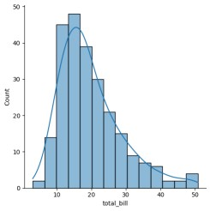

sns.displot(tips.total_bill,kde=False)

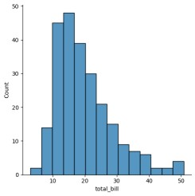

sns.jointplot(x=tips.tip,y=tips.total_bill)

<seaborn.axisgrid.JointGrid at 0x79bb08fc96c0>

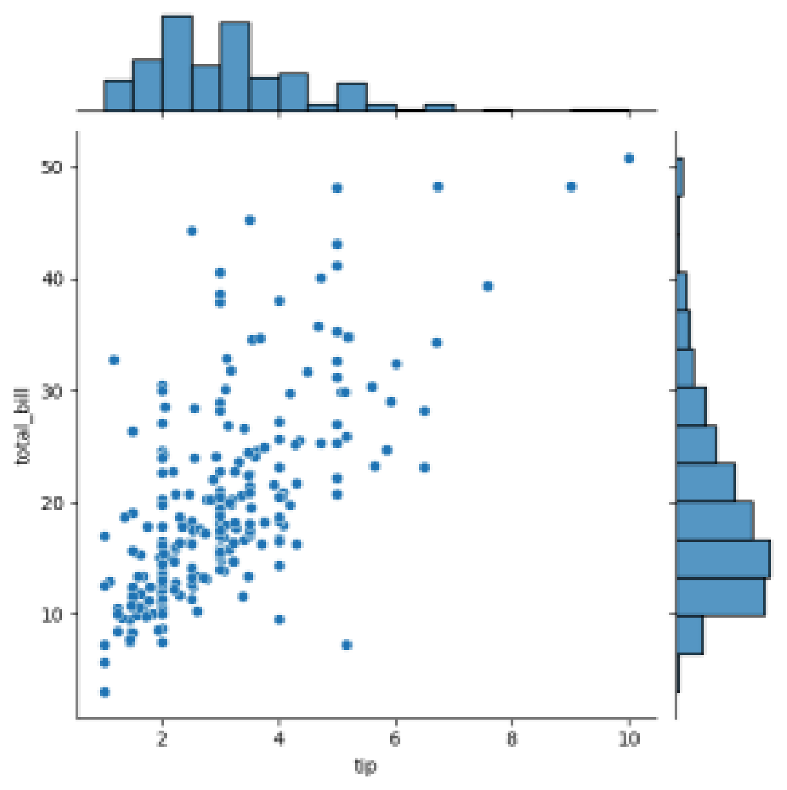

sns.jointplot(x=tips.tip,y=tips.total_bill,kind="reg")

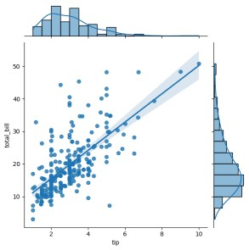

sns.jointplot(x=tips.tip,y=tips.total_bill,kind="hex")

<seaborn.axisgrid.JointGrid at 0x79bb088f4730>

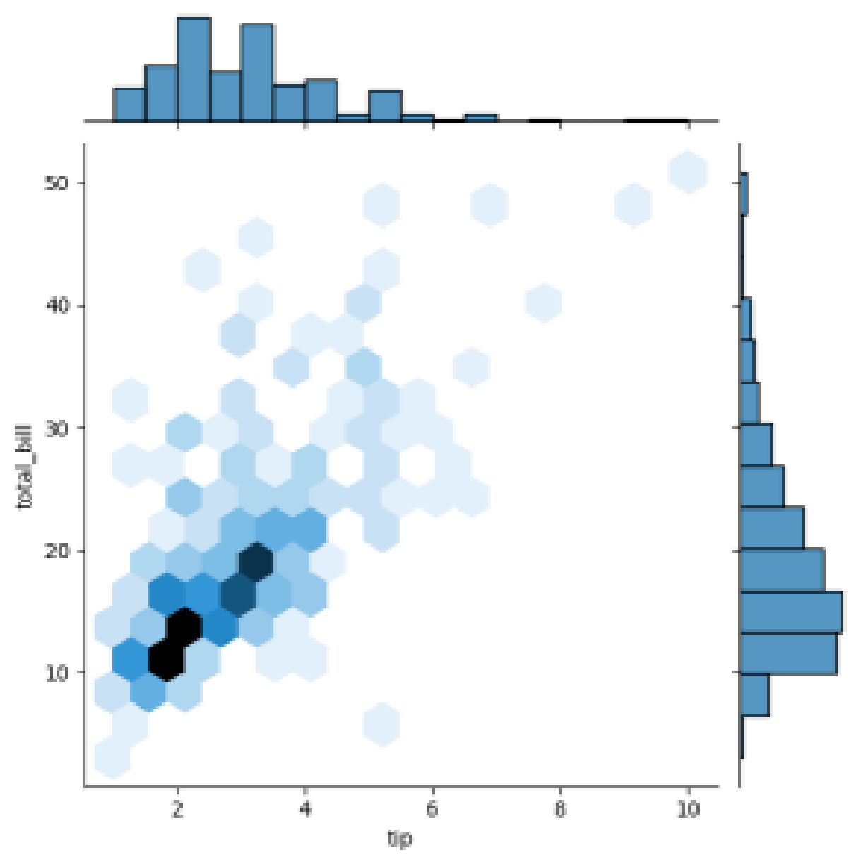

sns.pairplot(tips)

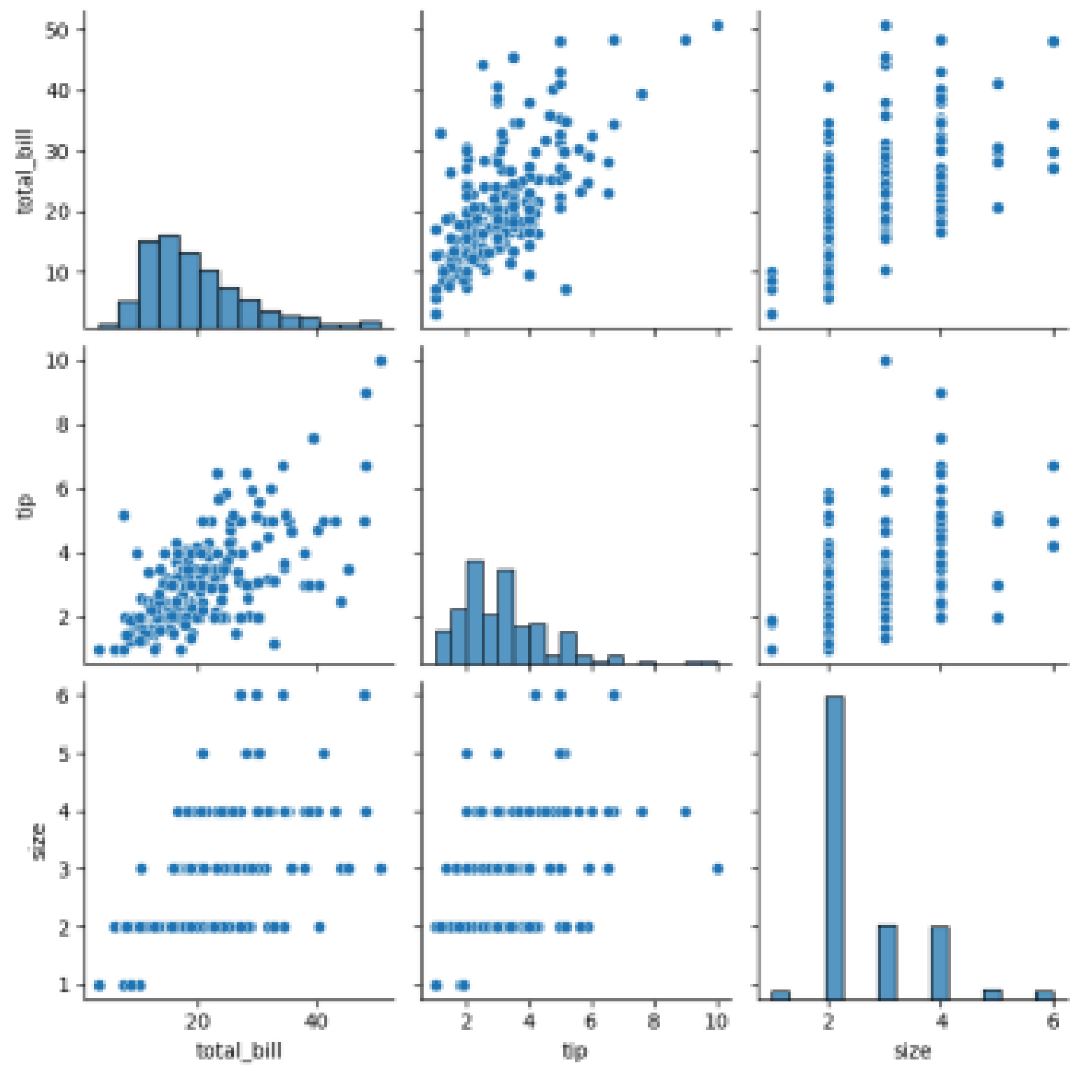

tips.time.value_counts() **count**

**time**

**Dinner** 176

**Lunch** 68 **dtype:** int64

sns.pairplot(tips,hue='time')

<seaborn.axisgrid.PairGrid at 0x79bb088f4670>

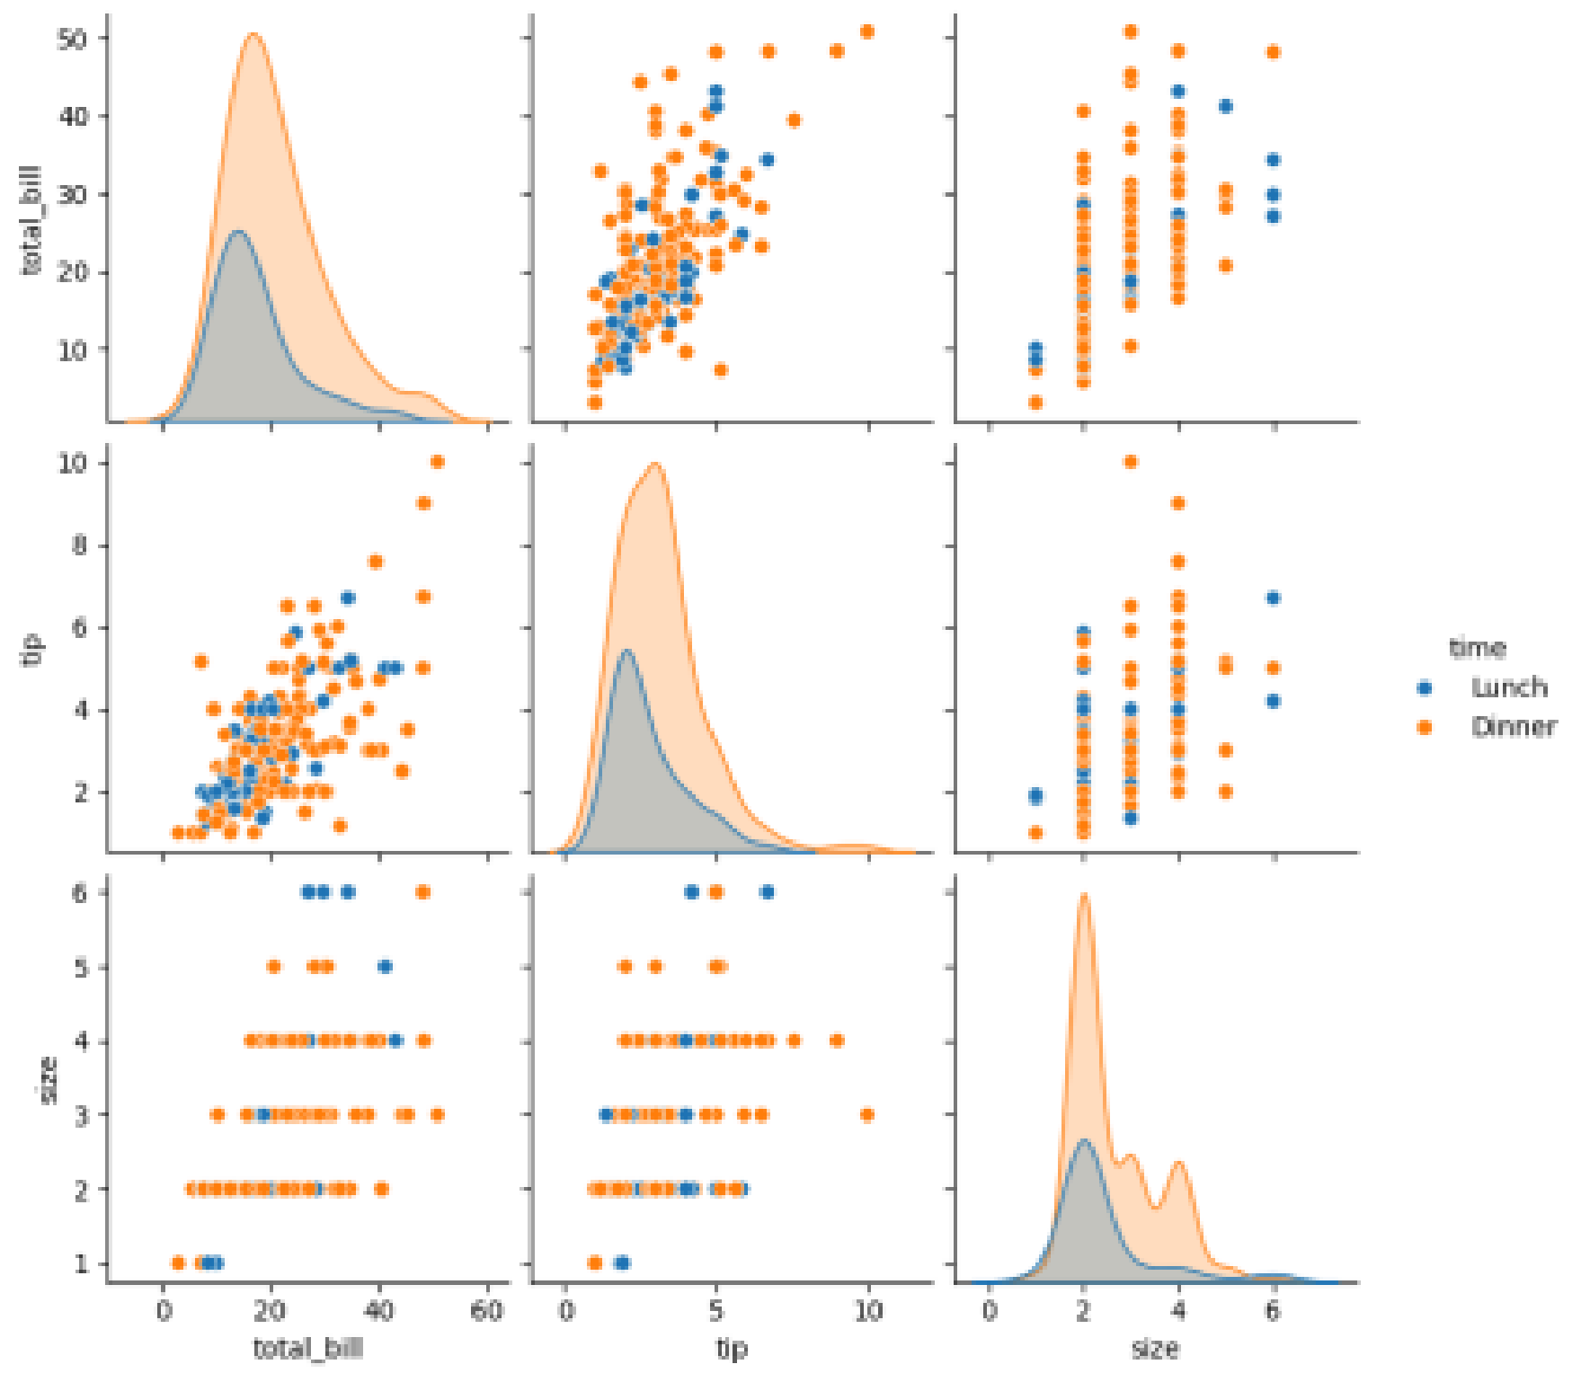

sns.pairplot(tips,hue='day')

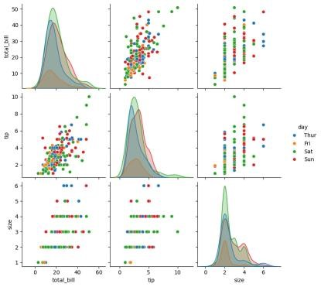

sns.heatmap(tips.corr(numeric_only=True),annot=True)

<Axes: >

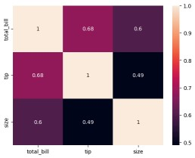

sns.boxplot(tips.total_bill)

<Axes: ylabel='total_bill'>

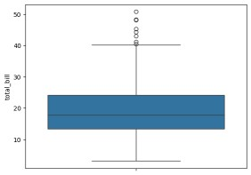

sns.boxplot(tips.tip)

<Axes: ylabel='tip'>

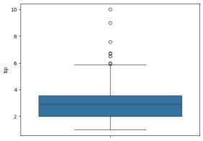

sns.countplot(tips.day)

<Axes: xlabel='count', ylabel='day'>

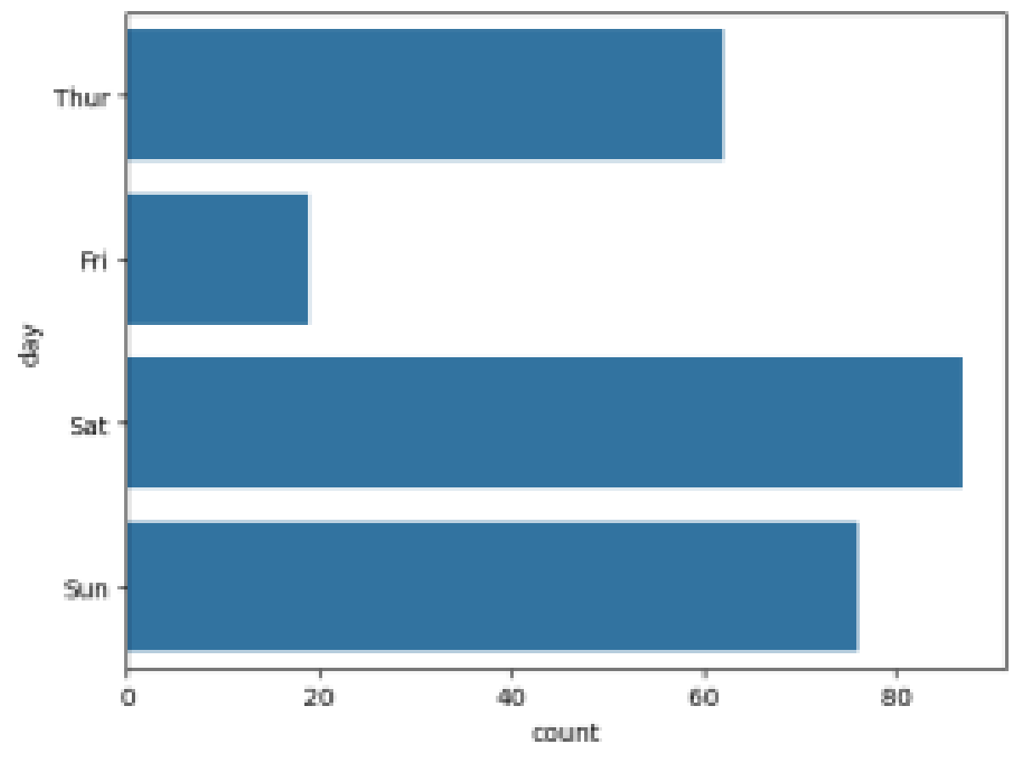

sns.countplot(tips.sex)

h<Axes: xlabel='count', ylabel='sex'>

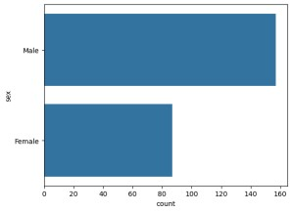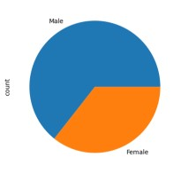

tips.sex.value_counts().plot(kind='pie')

<Axes: ylabel='count'>

tips.sex.value_counts().plot(kind='bar')

<Axes: xlabel='sex'>

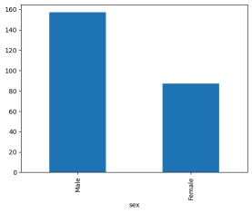

**Lab experiments**

**Roll no: 230701391**

**Name: Musa Haji**

**Class: CSE-C III**

**Subject: Fundamentals of data science (CS2334)**

**Experiment: 09**

# Column Non-Null Count Dtype --- ------ -------------- ----- 0 YearsExperience 30 non-null float64 1 Salary 30 non-null int64 dtypes: float64(1), int64(1) memory usage: 612.0 bytes df.dropna(inplace**=True**) df.info()

<class 'pandas.core.frame.DataFrame'> RangeIndex: 30 entries, 0 to 29

Data columns (total 2 columns):

# Column Non-Null Count Dtype --- ------ -------------- ----- 0 YearsExperience 30 non-null float64 1 Salary 30 non-null int64 dtypes: float64(1), int64(1) memory usage: 612.0 bytes df.describe()

Out[5]: **YearsExperience Salary count** 30.000000

30.000000 **mean** 5.313333 76003.000000 **std**

2.837888 27414.429785

**min** 1.100000 37731.000000

**25%** 3.200000 56720.750000

**50%** 4.700000 65237.000000 **75%** 7.700000 100544.750000 **max** 10.500000 122391.000000

In [6]:

features**=**df.iloc[:,[0]].values label**=**df.iloc[:,[1]].values

**from** sklearn.model_selection **import** train_test_split

x_train,x_test,y_train,y_test**=**train_test_split(features,label,test_size**=**0.2,random_ st

**from** sklearn.linear_model **import** LinearRegression model**=**LinearRegression() model.fit(x_train,y_train)

Out[20]: ▾ LinearRegression

LinearRegression()

model.score(x_tr In [21]: ain,y_train)

Out[21]: 0.9603182547438908

model.score(x_t In [23]: est,y_test)

Out[23]: 0.9184170849214232 model.coe In [24]: f_

Out[24]: array([[9281.30847068]]) model.inter In [25]: cept_

Out[25]: array([27166.73682891])

In [26]:

**import** pickle

pickle.dump(model,open('SalaryPred.model','wb')) model**=**pickle.load(open('SalaryPred.model','rb')) yr_of_exp**=**float(input("Enter Years of Experience: "))

yr_of_exp_NP**=**np.array([[yr_of_exp]]) Salary**=**model.predict(yr_of_exp_NP) Enter Years of Experience: 44

print("Estimated Salary for {} years of experience is {}: "

.format(yr_of_exp,Salary) Estimated Salary for 44.0 years of experience is [[435544.30953887]]:

**Lab experiments**

**Roll no: 230701391**

**Name: Musa Haji**

**Class: CSE-C III**

**Subject: Fundamentals of data science (CS2334)**

**Experiment: 10**

**import** numpy **as** np **import** pandas **as** pd

df**=**pd.read_csv('Iris.csv') df.info()

df.variety.value_counts()

Out[3]: Setosa 50

Versicolor 50

Virginica 50

Name: variety, dtype: int64

In [4]: df.head()

Out[4]: **sepal.length sepal.width petal.length petal.width variety 0** 5.1 3.5 1.4 0.2 Setosa **1** 4.9 3.0 1.4 0.2 Setosa **2** 4.7 3.2 1.3 0.2 Setosa **3** 4.6 3.1 1.5

0.2 Setosa **4** 5.0 3.6 1.4 0.2 Setosa

In [5]: In [6]: In [8]:

features**=**df.iloc[:,:**-**1].values label**=**df.iloc[:,4].values

**from** sklearn.model_selection **import** train_test_split **from** sklearn.neighbors **import** KNeighborsClassifier

xtrain,xtest,ytrain,ytest**=**train_test_split(features,label,test_size**=**.2,rando model_KNN**=**KNeighborsClassifier(n_neighbors**=**5) model_KNN.fit(xtrain,ytrain)

Out[8]: KNeighborsClassifier() print(model_KNN.score(xtrain,ytrain))

print(model_KNN.score(xtest,ytest))

0.9583333333333334 1.0

**from** sklearn.metrics **import** confusion_matrix confusion_matrix(label,model_KNN.predict(features))

Out[10]: array([[50, 0, 0],

[ 0, 47, 3],

[ 0, 2, 48]], dtype=int64) **from** sklearn.metrics **import** classification_report print(classification_report(label,model_KNN.predict(features))) precision recall f1-score support

Setosa 1.00 1.00 1.00 50 Versicolor 0.96 0.94 0.95 50 Virginica

0.94 0.96 0.95 50

accuracy 0.97 150 macro avg 0.97 0.97 0.97 150 weighted avg 0.97

0.97 0.97 150

**Lab experiments**

**Roll no: 230701391**

**Name: Musa Haji**

**Class: CSE-C III**

**Subject: Fundamentals of data science (CS2334) Experiment: 11**

In [1]: **import** numpy **as** np **import** pandas **as** pd df**=**pd.read_csv('Social_Network_Ads.csv') df

Out[1]: **User ID Gender Age EstimatedSalary Purchased 0** 15624510 Male 19 19000 0

**1** 15810944 Male 35 20000 0 **2** 15668575 Female 26 43000 0 **3** 15603246 Female 27 57000 0 **4** 15804002 Male 19

76000 0 **...** ... ... ... ... ...

**395** 15691863 Female 46 41000 1 **396** 15706071 Male 51 23000 1 **397** 15654296 Female 50 20000 1 **398** 15755018

Male 36 33000 0 **399** 15594041 Female 49 36000 1

400 rows × 5 columns

In [2]: df.head()

Out[2]: **User ID Gender Age EstimatedSalary Purchased**

1. 15624510 Male 19 19000 0
2. 15810944 Male 35 20000 0
3. 15668575 Female 26 43000 0
4. 15603246 Female 27 57000 0
5. 15804002 Male 19 76000 0

In [4]: features**=**df.iloc[:,[2,3]].values label**=**df.iloc[:,4].values features

Out[4]: array([[ 19, 19000], [ 35,

20000],

[ 26, 43000],

[ 27, 57000],

[ 19, 76000],

[ 27, 58000],

[ 27, 84000],

[ 32, 150000],

[ 25, 33000],

[ 35, 65000],

[ 26, 80000],

[ 26, 52000],

[ 20, 86000],

[ 32, 18000],

[ 18, 82000],

[ 29, 80000],

[ 47, 25000],

[ 45, 26000],

[ 46, 28000],

[ 48 29000]

In [5]: label

Out[5]: array([0, 0, 0, 0, 0, 0, 0, 1, 0, 0, 0, 0, 0, 0, 0, 0, 1, 1, 1, 1, 1, 1, 1, 1, 1, 1, 1, 1, 0, 0, 0, 1, 0, 0, 0, 0, 0, 0, 0, 0, 0, 0, 0, 0, 0, 0, 0,

0, 1, 0, 0, 0, 0, 0, 0, 0, 0, 0, 0, 0, 0, 0, 0, 1, 0, 0, 0, 0, 0, 0, 0,

0, 0, 0, 0, 1, 0, 0, 0, 0, 0, 0, 0, 0, 0, 1, 0, 0, 0, 0, 0, 0, 0, 0, 0,

0, 0, 1, 0, 0, 0, 0, 0, 1, 0, 0, 0, 0, 0, 0, 0, 0, 0, 0, 0, 0, 0, 0, 0,

0, 0, 0, 0, 0, 0, 0, 0, 0, 0, 0, 0, 0, 0, 0, 0, 0, 0, 1, 0, 0, 0, 0, 0, 0, 0, 0, 1, 0, 0, 0, 0, 0, 0, 0, 0, 0, 0, 0, 0, 1, 1, 0, 0, 0, 0, 0, 0,

0, 1, 0, 0, 0, 0, 0, 0, 0, 0, 0, 0, 0, 0, 0, 1, 0, 0, 0, 0, 0, 0, 0, 0,

0, 0, 0, 0, 0, 0, 0, 0, 0, 0, 0, 1, 0, 1, 0, 1, 0, 1, 0, 1, 1, 0, 0, 0,

1, 0, 0, 0, 1, 0, 1, 1, 1, 0, 0, 1, 1, 0, 1, 1, 0, 1, 1, 0, 1, 0, 0, 0,

1, 1, 0, 1, 1, 0, 1, 0, 1, 0, 1, 0, 0, 1, 1, 0, 1, 0, 0, 1, 1, 0, 1, 1, 0, 1, 1, 0, 0, 1, 0, 0, 1, 1, 1, 1, 1, 0, 1, 1, 1, 1, 0, 1, 1, 0, 1, 0, 1, 0, 1, 1, 1, 1, 0, 0, 0, 1, 1, 0, 1, 1, 1, 1, 1, 0, 0, 0, 1, 1, 0, 0, 1, 0, 1, 0, 1, 1, 0, 1, 0, 1, 1, 0, 1, 1, 0, 0, 0, 1, 1, 0, 1, 0, 0, 1,

0, 1, 0, 0, 1, 1, 0, 0, 1, 1, 0, 1, 1, 0, 0, 1, 0, 1, 0, 1, 1, 1, 0, 1,

0, 1, 1, 1, 0, 1, 1, 1, 1, 0, 1, 1, 1, 0, 1, 0, 1, 0, 0, 1, 1, 0, 1, 1,

1, 1, 1, 1, 0, 1, 1, 1, 1, 1, 1, 0, 1, 1, 1, 0, 1], dtype=int64)

In [6]: **from** sklearn.model_selection **import** train_test_split **from** sklearn.linear_model **import** LogisticRegression

**for** i **in** range(1,401):

x_train,x_test,y_train,y_test**=**train_test_split(features,labe l,test_size**=**0. model**=**LogisticRegression() model.fit(x_train,y_train)

train_score**=**model.score(x_train,y_train) test_score**=**model.score(x_test,y_test) **if** test_score**>**train_score:

print("Test {} Train{} Random State {}".format(test_score,train_score,i)

Test 0.6875 Train0.63125 Random State 3

Test 0.7375 Train0.61875 Random State 4

Test 0.6625 Train0.6375 Random State 5

Test 0.65 Train0.640625 Random State 6

Test 0.675 Train0.634375 Random State 7

Test 0.675 Train0.634375 Random State 8

Test 0.65 Train0.640625 Random State 10

Test 0.6625 Train0.6375 Random State 11

Test 0.7125 Train0.625 Random State 13

Test 0.675 Train0.634375 Random State 16

Test 0.7 Train0.628125 Random State 17

Test 0.7 Train0.628125 Random State 21

Test 0.65 Train0.640625 Random State 24

Test 0.6625 Train0.6375 Random State 25

Test 0.75 Train0.615625 Random State 26

Test 0.675 Train0.634375 Random State 27 Test 0.7 Train0.628125 Random State 28

Test 0.6875 Train0.63125 Random State 29

Test 0.6875 Train0.63125 Random State 31 T t 0 6625 T i 0 6375 R d St t 37

x_train,x_test,y_train,y_test**=**train_test_split(features,labe l,test_size**=**0.2, finalModel**=**LogisticRegression() finalModel.fit(x_train,y_train)

Out[8]: LogisticRegression() print(finalModel.score(x_train,y_train)) print(finalModel.score(x_test,y_test))

0.834375 0.9125

**from** sklearn.metrics **import** classification_report print(classification_report(label,finalModel.predict(features))) precision recall f1-score support 0 0.85 0.93 0.89 257 1 0.84 0.71 0.77 143

accuracy 0.85 400 macro avg 0.85 0.82 0.83 400 weighted avg 0.85 0.85

0.85 400

**Lab experiments**

**Roll no: 230701391**

**Name: Musa Haji**

**Class: CSE-C III**

**Subject: Fundamentals of data science (CS2334)**

**Experiment: 12**

**import** numpy **as** np **import** pandas **as** pd **import** matplotlib.pyplot **as** plt **import** seaborn **as** sns **%**matplotlib inline df**=**pd.read_csv('Mall_Customers.csv') df.info()

<class 'pandas.core.frame.DataFrame'> RangeIndex: 200 entries, 0 to 199

Data columns (total 5 columns):

# Column Non-Null Count Dtype --- ------ -------------- ----- 0 CustomerID 200 non-null int64 1 Gender 200 nonnull object 2 Age 200 non-null int64 3 Annual Income (k$) 200 non-null int64 4 Spending Score (1-100) 200 non-null int64 dtypes: int64(4), object(1) memory usage: 7.9+ KB df.head()

Out[4]: **CustomerID Gender Age Annual Income (k$) Spending Score (1-100)**

1. 1 Male 19 15 39
2. 2 Male 21 15 81
3. 3 Female 20 16 6
4. 4 Female 23 16 77
5. 5 Female 31 17 40

sns.pairplot(df) In [5]:

Out[5]: <seaborn.axisgrid.PairGrid at 0x170e8e47850>

features**=**df.iloc[:,[3,4]].values

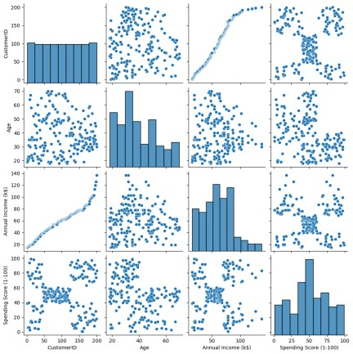In [6]:

In [7]: **from** sklearn.cluster **import** KMeans model**=**KMeans(n_clusters**=**5) model.fit(features) KMeans(n_clusters**=**5)

Out[7]: KMeans(n_clusters=5)

In [8]:

Final**=**df.iloc[:,[3,4]]

Final['label']**=**model.predict(features)

Final.head()

Final['label']=model.predict(features)

Out[8]: **Annual Income (k$) Spending Score (1-100) label**

1. 15 39 4
2. 15 81 2 **2** 16 6 4
3. 16 77 2
4. 17 40 4

In [9]: sns.set_style("whitegrid") sns.FacetGrid(Final,hue**=**"label",height**=**8) \

.map(plt.scatter,"Annual Income (k$)", "Spending Score (1-100)") \

.add_legend(); plt.show()

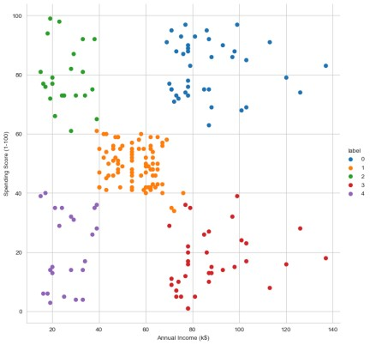

In [10]: features_el**=**df.iloc[:,[2,3,4]].values **from** sklearn.cluster **import** KMeans wcss**=**[] **for** i **in** range(1,10): model**=**KMeans(n_clusters**=**i) model.fit(features_el) wcss.append(model.inertia_) plt.plot(range(1,10),wcss)

Out[10]: [<matplotlib.lines.Line2D at 0x170e99f3550>]

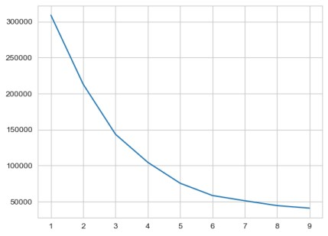

**Lab experiments**

**Roll no: 230701391**

**Name: Musa Haji**

**Class: CSE-C III**

**Subject: Fundamentals of data science (CS2334)**

**Experiment: 13**

import numpy as np

import matplotlib.pyplot as plt

# Step 1: Generate a population (e.g., normal distribution) population_mean = 50

population_std = 10 population_size = 100000 population = np.random.normal(population_mean, population_std, population_size)

# Step 2: Random sampling sample_sizes = [30, 50, 100] # different sample sizes to consider num_samples = 1000 # number of samples for each sample size

sample_means = {} for size in sample_sizes: sample_means[size] = [] for _ in range(num_samples):

sample = np.random.choice(population, size=size, replace=False) sample_means[size].append(np.mean(sample))

# Step 3: Plotting sampling distributions plt.figure(figsize=(12, 8))

for i, size in enumerate(sample_sizes): plt.subplot(len(sample_sizes), 1, i+1) plt.hist(sample_means[size], bins=30, alpha=0.7, label=f'Sample Size {size}') plt.axvline(np.mean(population), color='red', linestyle='dashed', linewidth=1.5, label='Population Mean') plt.title(f'Sampling Distribution (Sample Size {size})') plt.xlabel('Sample Mean') plt.ylabel('Frequency') plt.legend()

plt.tight_layout() plt.show()

OUTPUT:

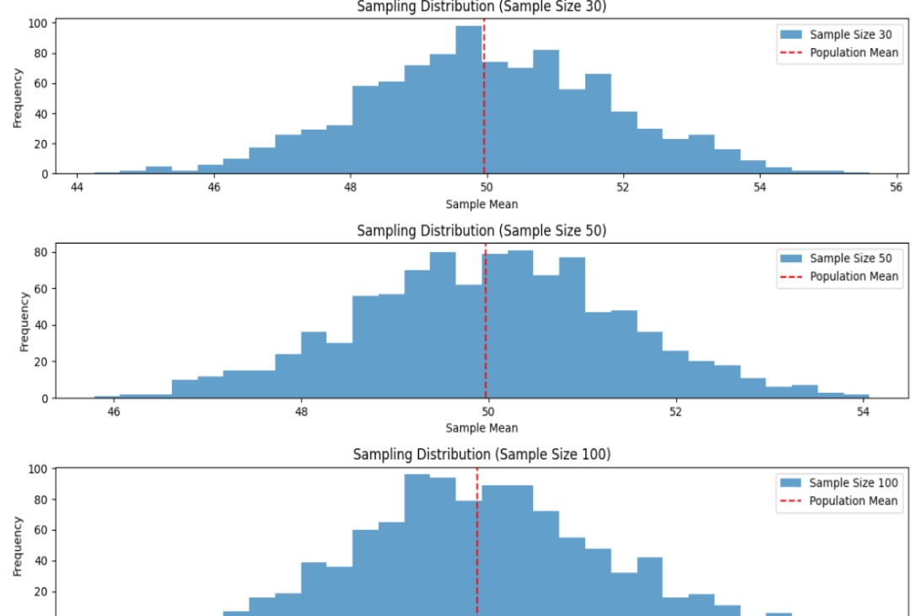

**Lab experiments**

**Roll no: 230701391**

**Name: Musa Haji**

**Class: CSE-C III**

**Subject: Fundamentals of data science (CS2334)**

**Experiment: 13**

import numpy as np import scipy.stats as stats

sample_data = np.array([152, 148, 151, 149, 147, 153, 150, 148, 152,

149, 151, 150, 149, 152, 151, 148, 150, 152,

149, 150, 148, 153, 151, 150, 149, 152,

148, 151, 150, 153])

population_mean = 150

sample_mean = np.mean(sample_data) sample_std = np.std(sample_data, ddof=1) n = len(sample_data)

z_statistic = (sample_mean - population_mean) / (sample_std / np.sqrt(n)) p_value = 2 * (1 - stats.norm.cdf(np.abs(z_statistic)))

print(f"Sample Mean: {sample_mean:.2f}") print(f"Z-Statistic: {z_statistic:.4f}") print(f"P-Value: {p_value:.4f}")

alpha = 0.05 if p_value < alpha: print("Reject the null hypothesis: The average weight is significantly different from 150 grams.") else: print("Fail to reject the null hypothesis: There is no significant difference in average weight from 150 grams.")

OUTPUT:

Sample Mean: 150.20

Z-Statistic: 0.6406

P-Value: 0.5218

Fail to reject the null hypothesis: There is no significant difference in average weight from 150 grams.

**Lab experiments**

**Roll no: 230701391**

**Name: Musa Haji**

**Class: CSE-C III**

**Subject: Fundamentals of data science (CS2334)**

**Experiment: 14**

import numpy as np import scipy.stats as stats # Set a random seed for reproducibility np.random.seed(42)

# Generate hypothetical sample data (IQ scores) sample_size = 25 sample_data = np.random.normal(loc=102, scale=15, size=sample_size) # Mean IQ of 102, SD of 15

# Population mean under the null hypothesis population_mean = 100

# Calculate sample statistics sample_mean = np.mean(sample_data) sample_std = np.std(sample_data, ddof=1) # Using sample standard deviation

# Number of observations

n = len(sample_data)

# Calculate the T-statistic and p-value

t_statistic, p_value = stats.ttest_1samp(sample_data, population_mean)

# Print results

print(f"Sample Mean: {sample_mean:.2f}") print(f"T-Statistic: {t_statistic:.4f}") print(f"P-Value: {p_value:.4f}")

# Decision based on the significance level alpha = 0.05 if p_value < alpha: print("Reject the null hypothesis: The average IQ score is significantly different from 100.") else: print("Fail to reject the null hypothesis: There is no significant difference in average IQ score from 100.")

**OUTPUT:**

Sample Mean: 99.55

T-Statistic: -0.1577

P-Value: 0.8760

Fail to reject the null hypothesis: There is no significant difference in average IQ score from 100.

**Lab experiments**

**Roll no: 230701391**

**Name: Musa Haji**

**Class: CSE-C III**

**Subject: Fundamentals of data science (CS2334)**

**Experiment: 15**

import numpy as np

import scipy.stats as stats

# Set a random seed for reproducibility np.random.seed(42)

# Generate hypothetical growth data for three treatments (A, B, C) n_plants = 25

# Growth data (in cm) for Treatment A, B, and C

growth_A = np.random.normal(loc=10, scale=2, size=n_plants) growth_B = np.random.normal(loc=12, scale=3, size=n_plants) growth_C = np.random.normal(loc=15, scale=2.5, size=n_plants)

# Combine all data into one array all_data = np.concatenate([growth_A, growth_B, growth_C])

# Treatment labels for each group

treatment_labels = ['A'] * n_plants + ['B'] * n_plants + ['C'] * n_plants

# Perform one-way ANOVA f_statistic, p_value = stats.f_oneway(growth_A, growth_B, growth_C)

# Print results

print("Treatment A Mean Growth:", np.mean(growth_A)) print("Treatment B Mean Growth:", np.mean(growth_B)) print("Treatment C Mean Growth:", np.mean(growth_C)) print()

print(f"F-Statistic: {f_statistic:.4f}") print(f"P-Value: {p_value:.4f}")

# Decision based on the significance level alpha = 0.05 if p_value < alpha: print("Reject the null hypothesis: There is a significant difference in mean growth rates among the three treatments.") else: print("Fail to reject the null hypothesis: There is no significant difference in mean growth rates among the three treatments.")

# Additional: Post-hoc analysis (Tukey's HSD) if ANOVA is significant

if p_value < alpha: from statsmodels.stats.multicomp import pairwise_tukeyhsd

tukey_results = pairwise_tukeyhsd(all_data, treatment_labels, alpha=0.05) print("\nTukey's HSD Post-hoc Test:") print(tukey_results)

OUTPUT:

Treatment A Mean Growth: 9.672983882683818

Treatment B Mean Growth: 11.137680744437432

Treatment C Mean Growth: 15.265234904828972

F-Statistic: 36.1214

P-Value: 0.0000

Reject the null hypothesis: There is a significant difference in mean growth rates among the three treatments.